DENGUE CONTINUATION SHEET

Date: ………………………. Time: …………………….
Seen with ……………………………...
Day of fever……………………. ( ONSET : ……………..)

New complaints: ………………………………………………………………….............

SYMPTOMS :
YES NO
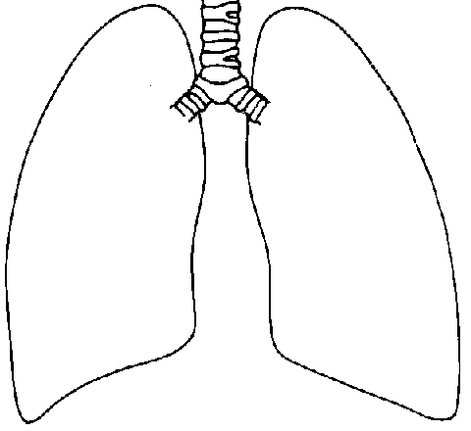
- Lethargy/restlessness
- Shortness of breath
- Headache
- Nausea / Vomiting
- Diarrhea
- Not tolerating orally
- Bleeding manifestation: Sites……………
- Restlessness
- Abdominal pain

Examinations: HEIGHT : ………. WEIGHT : ……….. IBW : ………….Kg

Vital Signs | Time ( ) | LUNGS  Any Effusion Yes No  Sites: Right / Left / Bilateral
Temperature |  | LUNGS  Any Effusion Yes No  Sites: Right / Left / Bilateral
Heart Rate |  | ABDOMEN  Ascites Yes No  Tenderness Yes No  Sites:  Hepatomegaly Yes No
BP
Pulse Pressure
Respiratory Rate
Extremities | Cold Warm | CNS Normal  Abnormal , Specify
Hydration | Normal Dehydrated | BLEEDING  Yes No  Sites:
SpO₂ (for DHF) |  | BLEEDING  Yes No  Sites:

TO INFORM IF Tacchycardia Or SBP < 90mm Hg Or MAP < 70 mmHg ⎨MAP = (2xDBP) + SBP } Or Pulse pressure (PP) < 20mmHg ( Warning sign ) (Pulse pressure = SBP – DBP)

OtherFindings: ……………………………………………………………………………………………

……………………………………………………………………………………………………...............

……………………………………………………………………………………………………..............

- Diagnosis
Please include/ refer to the following in your diagnosis
    - Day ___ of illness ( Date of fever onset: .....)
    - Dengue without warning signs / with warning signs / resolved warning signs
- if warning signs are present : What are the alarm signs? ( abdominal pain/
tenderness, persistent vomiting , 3rd space fluid accumulation ,
mucosal bleed , if present , where ? , lethargy , restlessness, tender
hepatomegaly , Increase in HCT associated with rapid decrease in platelet count )

- any organ impairment or complications : eg, hepatitis , myocarditis, encephalitis , haemphagocytic syndrome , etc

- Evidence of plasma leakage : Hct , pleural fluid, ascites

Or
Severe dengue with severe plasma leakage / severe haemorrhage/ severe organ
impairment , specify site

- Phase : Febrile / Critical ( defeverscence ___ hours / Recovery
- Shock : none / compensated / decompensated/ resolved shock
- Comorbidities / special situations : pregnancy , elderly , DM ., HPT etc

IN THE PRESENCE OF ANY WARNING SIGNS , NEED IMMEDIATE ACTION AND PLEASE SEEK SENIOR CONSULT

CURRENT DIAGNOSIS :

............................................................................................................................................................
..........................................................................................................................................................

..........................................................................................................................................................

..........................................................................................................................................................

Management:

- Fluid management
Stop intravenous fluid
Fluid Resuscitation
Maintenance
( Type : crystalline / colloid / Blood / blood product
Amount eg,ml / kg /body weight / hour or 1.5 maintenance
Rate : ml / hour or 1 pint over 2 hours if not on infusion pump)
Duration : for how many hours , include time fluid start and ends )
...............................................................................................................................................................................................................................................................................................................................................................................................................................................................................
.2. Investigation
* FBC / HCT/ Renal profile / Liver profile including ALT , AST , Creatine Kinase
* PT/APTT
* BFMP ( travel history , Foreigners )
* Lactate / HCO₃ / Ferritin / LDH / GSH / GXM when indicated eg. in severe
dengue
* ECG / CXR
* Time of resuts to be traced
* Time for patient to be reviewed

Investigation ordered : ( Please refer to above )
........................................................................................................................................................................................................................................................................................................................4.5 Medications and other Managements: …………………………………………............

………………………………………………………………………………………………

………………………………………………………………………………………………

Clerked by:……………………………..
Signature………………………….....

